ECE 3331

INTRODUCTION TO SIGNAL PROCESSING

ZIQIN SHANG

250890594

1. (10 points) Perform sampling of this signal using sampling frequency Fs = 10 Hz to obtain the discrete time signal x[n].

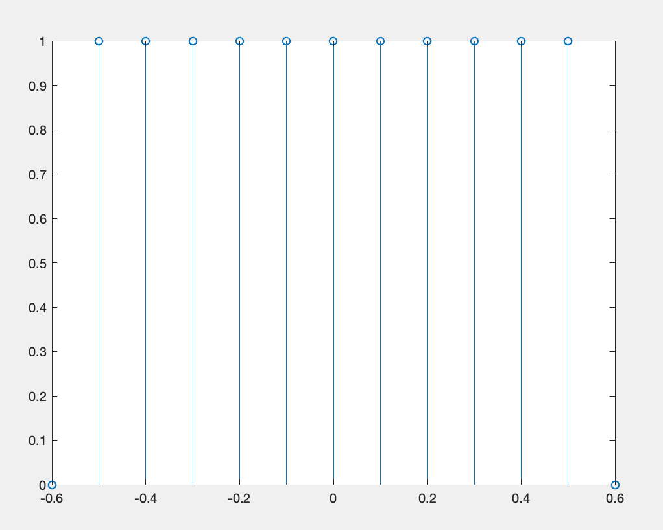

Figure1. X(n) while Fs = 10Hz

2. (40 points) Write a MATLAB script to calculate the discrete-time Fourier transform (DTFT) of the discrete signal x[n] using the equation

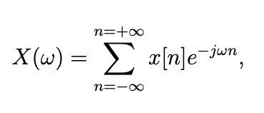

where ω = Ω/Fs is the discrete-time frequency, ω ∈ [−π, +π] rad.

Please see attached code.

3. (5 points) Plot the calculated X(ω) (use 0.01 rad as the discrete-time frequency resolution for calculations and plotting).

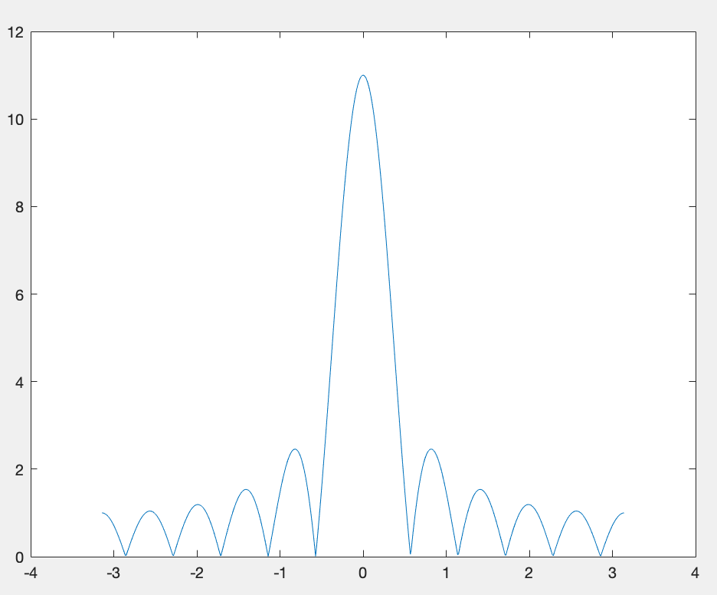

Figure 2. X(w) with 0.01 rad

4. (25 points) Generalize your script and create a MATLAB function which calculates the DTFT of any input signal. The function should take a discrete-time input signal and a discrete-time frequency resolution as inputs and generate the DTFT of the input signal as its output.

Please see attached code.

5. (10 points) Apply the input signal

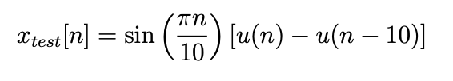

(sampled at 20 Hz) to the function using the same discrete-time frequency resolution as before.

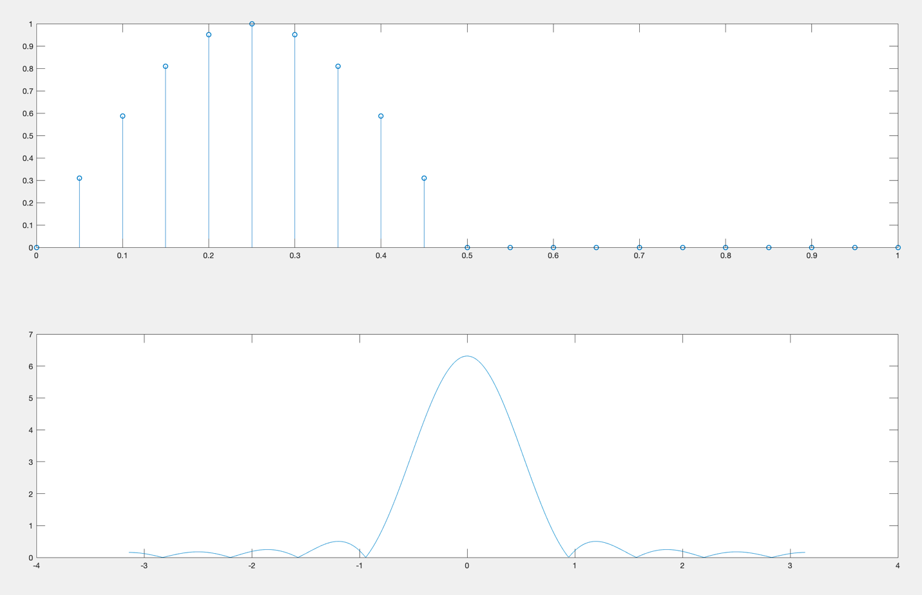

Figure 4. xtest(n) @ 20Hz

6. (10 points) Plot the resulting DTFT vs. real frequencies in Hz.

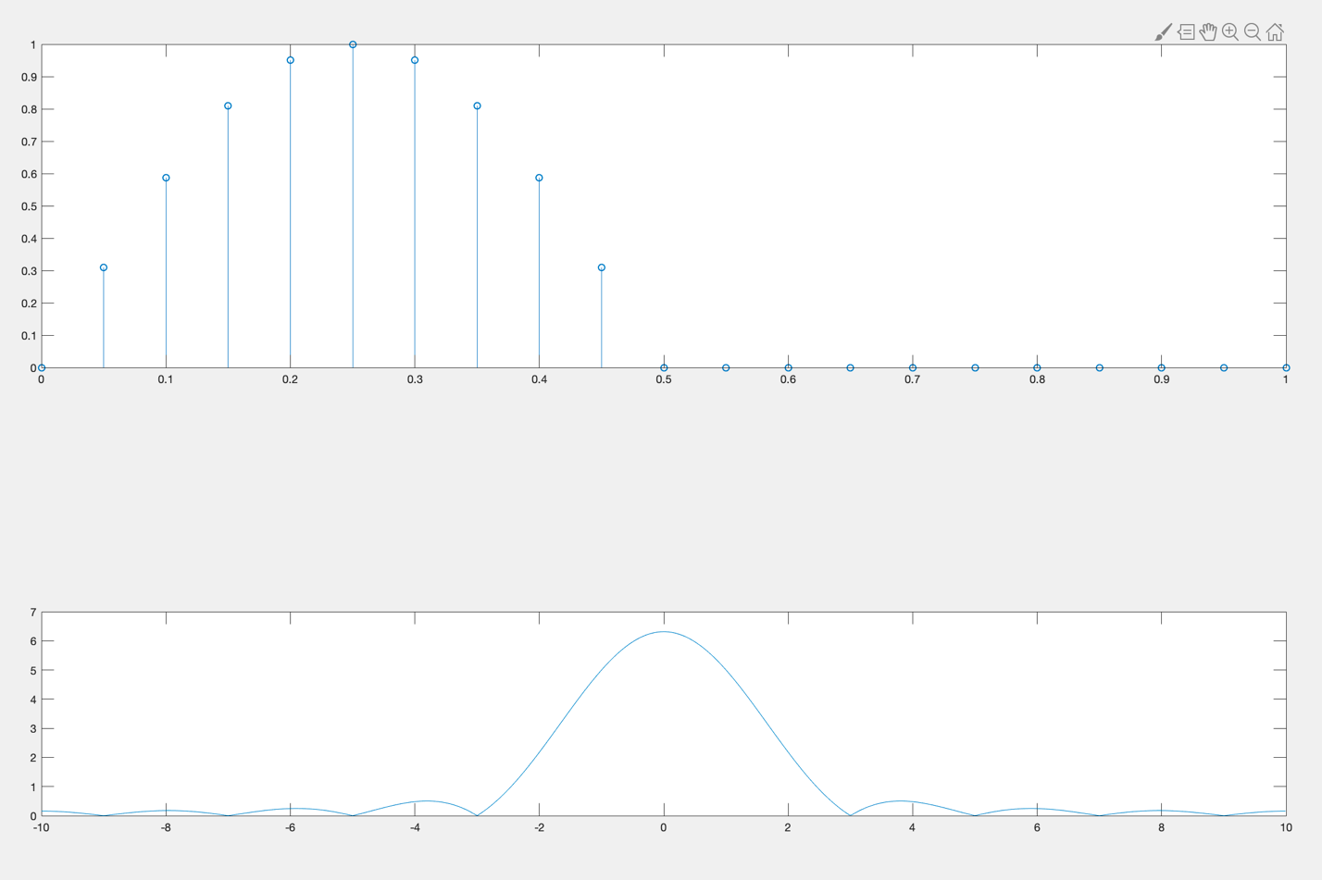

Figure5. DTFT

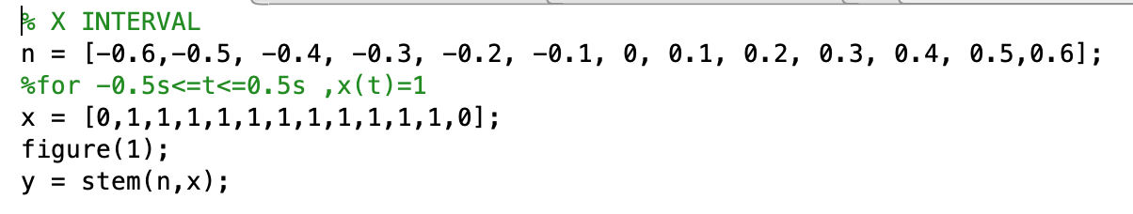

Figure6. Question 1 executed code

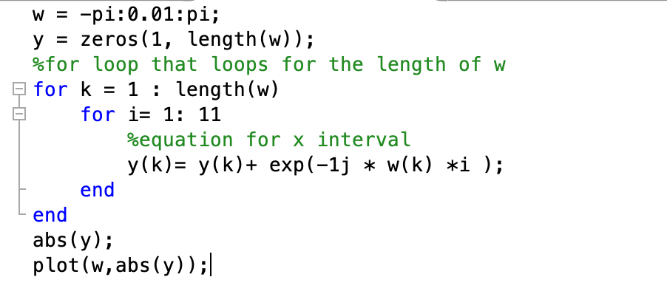

Figure7. Question 2 executed code

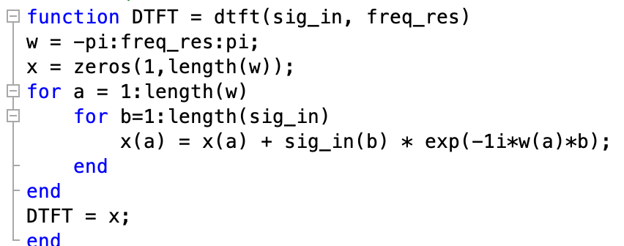

Figure8. Question 4 executed code

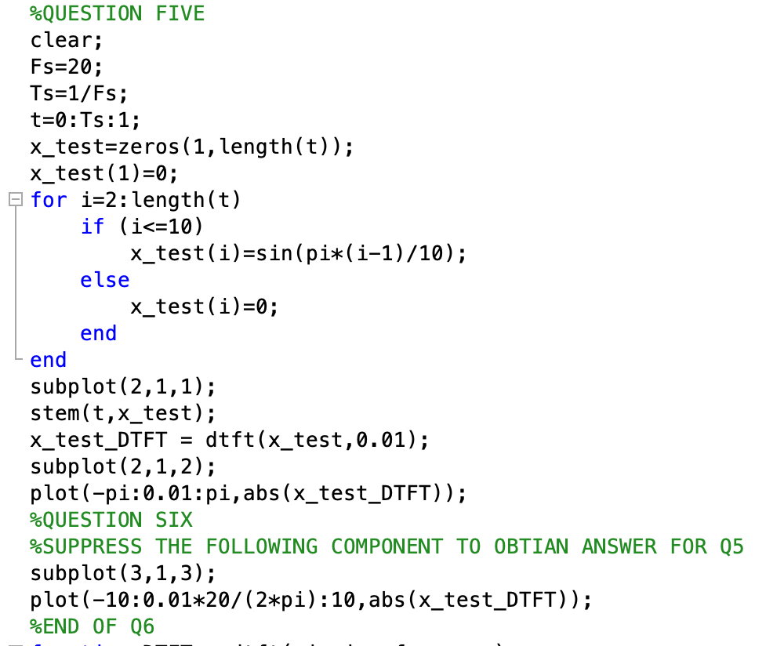

Figure9. Question 5 and 6 executed code